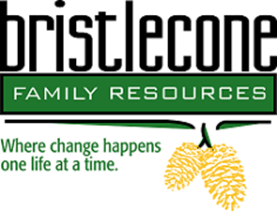

Bristlecone Family Resources is northern Nevada’s oldest non-profit substance abuse and gambling treatment center whose mission is to help people reclaim their lives by providing customized addiction and mental wellness treatment services.
We are seeking applications for full-time Counselor / CADC -I / CADC or LADC focused on the skills to coordinate and provide direct services to clients engaged in residential and outpatient treatment.
Duties include:
Assessing, diagnosing, and treating
Facilitate group & Individual sessions
Carrying caseload
Developing treatment plans, discharge plans, and other clinical documentation, which is entered on state computer system LS, Lightening Step
Case management
Crisis intervention consultation
Job requirements:
- Basic understanding of ASAM, Cognitive Behavioral Therapy, Motivational Interviewing, and Matrix Model.
- Bachelor’s degree in social services or related field or currently enrolled in bachelor’s program
- State of Nevada Board of Examiner’s CADC or CADCI credentials.
- Bi-lingual is a plus but not required.
- Computer proficiency.

If this area is of interest to you please briefly outline your experience and qualifications.

Compensation $DOE

We offer a full benefits package including medical, dental and vision / PTO and 12 paid holidays

Those interested and qualified, please submit resume to Human Resources at 775-954-1406 or email resume to kmanguso@bristleconereno.com.
The selected candidate will need to complete a preplacement health screening

