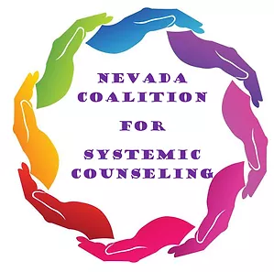

Job Description: Executive Director
Updated: 12/2024

Description
The Executive Director provides leadership for the development and sustainability of the Nevada Coalition for Systemic Counseling (NCSC). This position is accountable for all operations of NCSC including fiscal management, fundraising, programmatic implementation and success, organizational development, and volunteer supervision. The position works closely with the NCSC Board of Directors.

Duties
- Overall Organization Responsibilities
- Achieve an understanding of organization mission, strategic focus areas and overall goals and objectives
- Develop organization policy and procedures as needed
- Review operating practices and implement improvements where necessary
- Maintain username and passwords for all software and online accounts used by the organization
- Fiscal Responsibilities
- Provide leadership and oversight of the organization’s 501(c)3 nonprofit status
- Develop annual budget and conduct monthly fiscal monitoring
- Works with the Board of Directors and contract accountant to assure fiscal policies are followed
- Coordination of Board of Directors
- Arrange and coordinate Board meetings and Committee meetings
- Assist with preparing agenda for Board meetings
- Distribute minutes of Board meetings
- Attend monthly Board meetings
- Works with committee chairs to support the committee’s function and development
- Coordination of Programming and Member Benefits
- Work with the board to plan and implement continuing education events
- Coordinate quarterly online article presentations
- Coordinate quarterly social events
- Prepare quarterly newsletter
- Prepare and edit correspondence, communications, presentations and other documents
- Design and maintain databases
- Monitor, screen, respond to and distribute incoming communications
- Answer and manage incoming emails for NCSC
- Assist with coordinating NCSC events such as Mentoring Day

Position Details
- This is an independent contractor position
- Salary $35-$45 per hour depending upon experience (up to $10,000 per year)
- Variable hours per week

Qualifications and Requirements

Knowledge of/Experience in:
- Leadership, inclusive of strategic planning and fund development aligned with accelerating organizational performance, impact, effectiveness and growth
- Demonstrated commitment to diversity, equity and inclusion including the ability to effectively engage and support meaningful participation from impacted populations
- Strong, concise written and verbal communication skills
- Strong understanding of community needs and consensus building ability
- Minimum bachelor’s degree in human services, social work, early childhood, psychology, public administration or related field
- Two years of supervisory and administrative experience; to include supervision of staff, fiscal management, team and program development, quality assurance and performance evaluation
- Must possess a valid Nevada Driver’s License, and have current insurance if using a personal vehicle for company work
- Must have access to reliable internet service for work related activities

**To apply, please submit a cover letter and resume to nevadacsc2019@gmail.com

