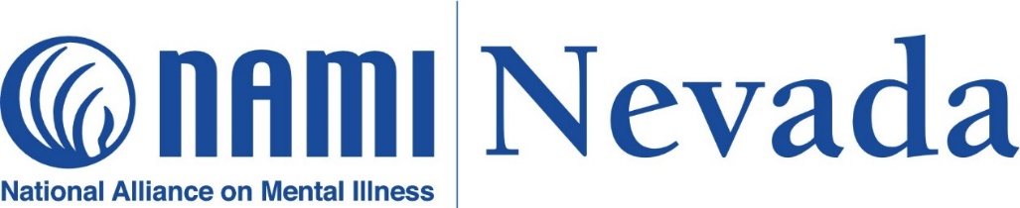

988 Task Force Coordinator and DATA Specialist
JOB DESCRIPTION

Job Title: 988 Taskforce Coordinator & DATA Specialist
Position Type: Fulltime, Exempt and Hybrid
Location: Reno, Nevada
Position Reports to: NAMI Nevada Executive Director

NAMI Nevada is the National Alliance on Mental Illness (NAMI) Nevada chapter. Our mission is “The improvement of the quality of life for persons who are affected by mental illnesses, by providing education, support, and advocacy.” The state organization supports and develops local affiliates and addresses the needs of the membership. Our main goal is to provide services and referrals for people and their families living with a mental health condition. We provide educational classes that help people, and their families navigate through the diagnosis, and prescribed medications to help them better understand how to navigate the mental healthcare system in this state. NAMI Nevada is also at the forefront of policy and advocacy in the state for mental illness.

GRANT OBJECTIVE:
The primary goal of this project is to ensure that community partners and entities across Nevada are well-equipped and prepared to integrate with the 988 services hub, catering to their specific needs to ensure the successful application of 988 services within the county, region, and State. This involves the understanding of the challenges in integration, proposing solutions to barriers and recognizing current and new structures supporting the establishment and implementation of crucial mental health crisis infrastructure. The 988 Taskforce is to validate the needs/benefits in an individual region so the establishment of Designated Mobile Crisis Teams (DMCT) and Crisis Stabilization Centers (CSC's) are effective and efficient to help, support, and guide the implementation of the components for stakeholders.

Job Summary:
The 988 Taskforce Coordinator and DATA Specialist is the central informational hub. The position will create/retain from the Substance Abuse and Mental Health Services Administration (SAMHSA) informational material; interact with the State, crisis line providers and leaders in this grant on complaints/feedback, and suggestions for improvement each week; deliver progress reports on community preparedness, integration challenges/successes and adapt strategies based on ongoing evaluations to ensure continuous improvement and effective integration. The position will organize the dissemination of Taskforce meeting agendas, and minutes, maintain contact lists, and oversee the progress of the contract staff and contracted affiliate partners through weekly meetings with Lead Contractor and Executive Director (ED). He/she will attend all Nevada Regional Behavioral Health Policy Board (NRBHPB) meetings and work directly with their coordinators to recruit taskforce members/volunteers. The position will send monthly reports on scope of work progress noting deadlines which will include information from ED, Crisis Intervention Trainer (CIT) Program Staff, and Contracted Affiliate Partners; all relevant data will be reported monthly including feedback from regions to the grantor. As Data Specialist he/she will verify/audit the documentation received by reporting parties every six months.

This can be a challenging yet fun and rewarding position for the right person with the skillset, communication, and ability to work well with others and independently, as well as meet the demands of the position.

Responsibilities and Duties:
- Assist in the planning and overseeing significant 988 events.
- Research, collect and coordinate 988 information and create an educational library of information from NAMI National, SAMHSA, and crisis services from across the nation.
- Schedule monthly 988 education discussion meetings with NAMI Staff, affiliate partners/contractors, scheduled via Zoom to plan for coordinated Outreach Activities.
- Interview potential Taskforce Members who are recommended by NRBHPB coordinators and submit recommendations in NAMI Nevada weekly meetings with the ED, COO, and contractor.
- Maintain a 988-contact database.
- Maintain a Rolling Schedule of all outreach activity.
- Coordinate Outreach Activity by dates and times, purchase or print materials for each townhall, ensure timely delivery of materials to participants before the townhall training, and maintain the final attendee sign-in sheet for every event scheduled under this grant.
- Liaison with NAMI National for 988 meetings.
- Comply with NAMI Nevada’s records retention schedule for all documents.
- Create, plan and coordinate NAMI Nevada's Annual 988 report, including any other reports required under this grant.
- Work with NAMI Nevada COO to craft engaging fliers and promotional materials for 988 events to effectively reach target audiences.
- Foster community participation and support of the 988 Taskforce meetings and the Educational Townhalls offered across Nevada.
- Assist with the coordination of other subgrant award projects as needed.
- Assist the ED at presentations as needed.
- Interact with crisis line providers, warmline and teen text line providers and leaders in this grant on complaints/feedback, and suggestions for 988 improvements, deliver progress reports on community preparedness, integration challenges/successes and adapt strategies based on ongoing evaluations to ensure continuous improvement and effective integration each week.
- Meet with regional partners and the State to discover best practices and lessons learned.
- Attend Taskforce meetings and take roll call and minutes.
- Respond to communications (via emails, phone calls, or text messages) from staff, partners, members, Affiliates and Grantor regarding 988.
- Attend in-person staff meetings.
- Prepare letters and reports as needed.
- Assist in the planning and overseeing significant 988 events.
- Make reservations for various off-site business meetings.
- Obtain preapprovals from the ED for anticipated expenses in accordance with NAMI Nevada’s policies.
- Relay internal emails to staff.
- Provide monthly report update noting deadlines which will include information from ED, CIT Program Staff, and Contracted Affiliate Partners; all relevant data will be reported monthly including feedback from regions to ensure NAMI Nevada’s ED, Grantor and State Board are aware of current activities related to 988.
- Additional duties as assigned.

Qualifications and Skills:
- High School Diploma or GED, bachelor’s degree preferred.
- 5 years’ experience with primary responsibility of business development/marketing and two years’ experience in Non-profit Operational Management, Project Management and or other similar duties.
- At least 1 year of grant writing, grant reporting and monitoring.
- Proficient in the use of the Microsoft Suite of products, including Excel, is required.
- Familiar with Google form docs and forms is a plus.
- Electronic record keeping and organizational skills.
- Ability to communicate both verbally and in writing with professionalism.
- Ability to prioritize work tasks, work independently and collaboratively to meet deadlines.
- Ability to prioritize self-care, avoid burnout, seek assistance, and request time off when needed.

Salary and Benefits:
- This position is funded by a grant through April 2025. Its continuance is dependent on successful grant renewal.
- Salary is tailored to match the candidate’s experience and qualifications. We are committed to offering a competitive compensation package that reflects the expertise and value brought by the candidate to our organization. While we strive to secure long-term funding, we want to be transparent about the potential variability in the duration of this position.
- Flexible work schedule.
- Ability to work independently.
- Ability to work remotely approximately 50% of the time.
- Generous policies of paid sick leave, annual leave, and holiday pay.

