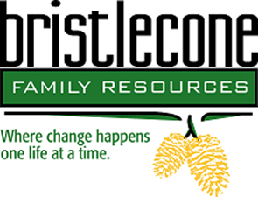

Bristlecone Family Resources is northern Nevada’s oldest and largest non-profit substance abuse and gambling treatment center whose mission is providing strengths-based addiction and mental health services, we will bring treatment to an underserved population of individuals suffering from substance use, gambling, and psychological challenges that may otherwise not have access to care.
We are seeking applications for full-time Certified Problem Gambling Counselor / Intern, possessing the skills to coordinate and provide direct services to clients engaged in residential and outpatient treatment.
Duties include:
Assessing, diagnosing, and treating.
Facilitate group & Individual sessions.
Carrying caseload of 25+.
Developing treatment plans, discharge plans, and other clinical documentation which is entered on state computer system Lightening Step.
Case management
Crisis intervention consultation.
Job requirements:
- Basic understanding of ASAM, Cognitive Behavioral Therapy, Motivational Interviewing, and or Matrix Model.
- Bachelor’s degree in social services or related field or currently enrolled in bachelor’s program.
- State of Nevada Board of Examiner’s PhD, MFT, LCSW, CADC,CADCI, CPGC/I credentials.
- Bi-lingual is a plus, but not required.
- Computer proficiency.
- Schedules may vary to include some weekends and holidays.

Additional requirements: BFR is a leader in co-occurring disorders, gambling, criminal justice/court supervised clients. If this area is of interest to you, please briefly outline your experience and qualifications.

Compensation varies by DOE.

We offer a full benefits package including medical, dental and vision.

Those interested and qualified, please submit resume to Human Resources @ kmanguso@bristleconereno.com.
The selected candidate will need to complete a preplacement health screening.

