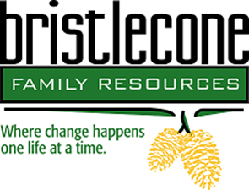
Bristlecone Family Resources is northern Nevada’s oldest non-profit substance abuse and gambling treatment center whose mission is to help people reclaim their lives by providing customized addiction and mental wellness treatment services.

Title: Licensed Certified Counselor / Intern / Male Residential Floor
Location: 704 Mill Street Reno NV
Schedule: Monday – Friday 9am – 6pm / Full benefits and competitive wages
Job Posting: June 2021
Salary range: DOE
The primary responsibility of this position is to ensure Bristlecone offers quality services that meet best practices and are evidence based. This position will oversee our clients residing on the male residential unit.
General duties include (but not limited to):
- Assessing, diagnosing and treating clients.
- Facilitate groups & Individual sessions.
- Carrying a case load.
- Developing treatment plans, discharge plans, and other clinical documenting which is entered on the state EHR system, ZEN.
- Case management.
Job requirements:

- Basic understanding of ASAM, Cognitive Behavioral Therapy, Motivational Interviewing, and or Matrix Model.
- Bachelor’s degree in social services or related field or currently enrolled in the Bachelors program.
- State of Nevada Board of Examiner’s PhD, MFT, LCSW, LADC & CADC
- Demonstrates a thorough understanding of 42 CFR Part 2 and 45 CFR (HIPAA).

If you are interested and qualified, please fax your resume to Kristin Manguso, Human Resources Manager at (775) 954-1406 or email resume to kmanguso@bristleconereno.com

The selected candidate will need to complete a pre-placement health screening and a two-series TB test.

Bristlecone Family Resources is an EOE.

