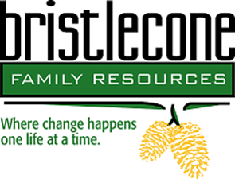

Bristlecone Family Resources is northern Nevada’s oldest non-profit substance abuse and gambling treatment center whose mission is to help people reclaim their lives by providing customized addiction and mental wellness treatment services.
Title: Clinical Director
Location: Bristlecone Family Resources 704 Mill Street Reno NV
Job Posting: October 2019 until filled
Salary range: DOE
The primary responsibility of this position is to assist in to ensure Bristlecone offers quality services that meet best practices and are evidence based.
General duties include (but not limited to):
- Has working knowledge of the programs provided.
- Responsible for integrating into daily operations the core values and mission of the organization.
- Demonstrates a thorough understanding of the 42 CFR Part 2 and 45 CFR (HIPPA).
- Maintains data and reports for grant compliance as required.
- Adheres to the BFR’s Code of Ethics.

The successful candidate will possess:

- Current State of Nevada License as an alcohol and drug abuse counselor (LADC / CADC).
- Must be certified as a Clinical Supervisor.
- Must hold a Master’s Degree in the Behavioral Sciences or related field.
- A minimum of two (2) years’ experience in management.

If you are interested and qualified, please fax your resume to Kristin Manguso, Human Resources Manager at (775) 954-1406 or email resume to kmanguso@bristleconereno.com

The selected candidate will need to complete a pre-placement health screening and a two-series TB test.

Bristlecone Family Resources is an EOE

