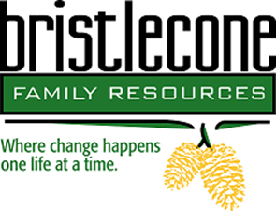

Bristlecone Family Resources is northern Nevada’s oldest non-profit substance abuse and gambling treatment center whose mission is to help people reclaim their lives by providing customized addiction and mental wellness treatment services.
Title: Treatment Aide; Monday – Friday 245pm – 1115pm. Full benefits and competitive wages.
Location: Bristlecone Family Resources 704 Mill Street Reno NV
Job Posting: September 2019
Salary range: $12.50 – 14.50
The primary responsibility of this position is to ensure and coordination the consistency of client treatment alongside addiction counselors and staff.
You must be will to:
- Achieve and maintain certifications in CPR and First Aid
- Conducts daily activities to ensure ongoing safety and security of clients
- Oversees the daily schedule for clients including wake/bed times, group times, and meal times
- Assists with community and group meetings as well as recreational activities
- Facilitates drug testing and breathalyzer.
- Ability to maintain confidentiality.

The successful candidate will possess:

- Experience with Microsoft Word, internet and e-mail, AWARDS a plus.
- Willingness to work 12 hour day or night shifts
- Excellent organizational and time management skills
- Excellent verbal and written skills
- Bi-lingual is a plus, but not required.
- EMT Certification a plus, not required.

Those interested and qualified, please submit your resume to Human Resources at 775-954-1406 or email resume to kmanguso@bristleconereno.com

The selected candidate will need to complete a preplacement health screening and a 2 series TB test.

Bristlecone Family Resources is an EOE

